**Module 9 - Challenge Lab: Creating a Scalable and Highly Available Environment for the Café**

### Task 1: Inspecting your environment

Answer the questions:

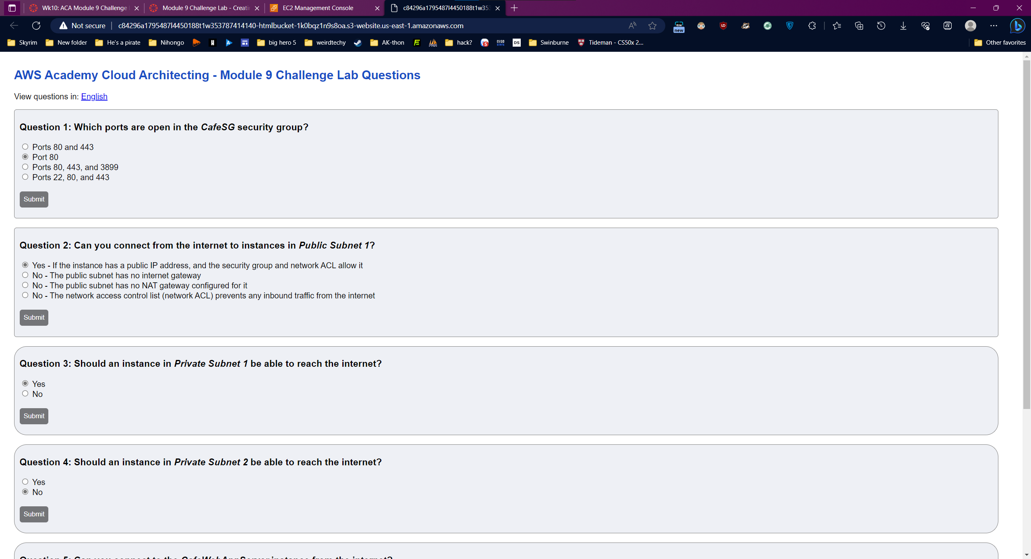

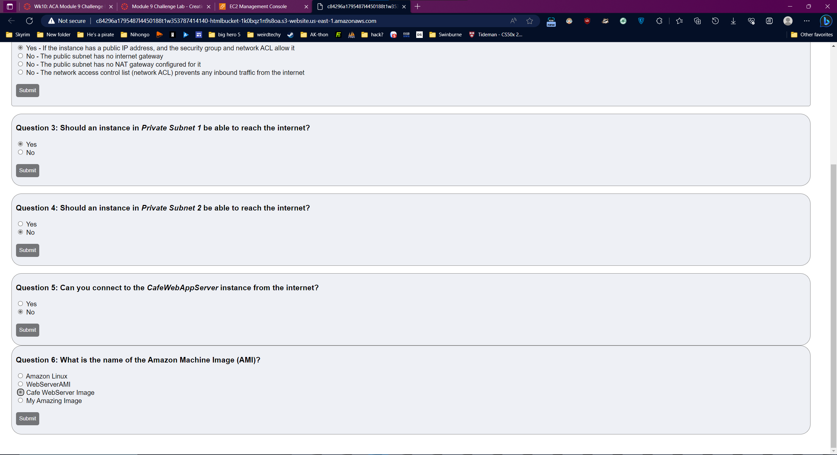

### Task 2: Creating a NAT gateway for the second Availability Zone

Create a NAT gateway

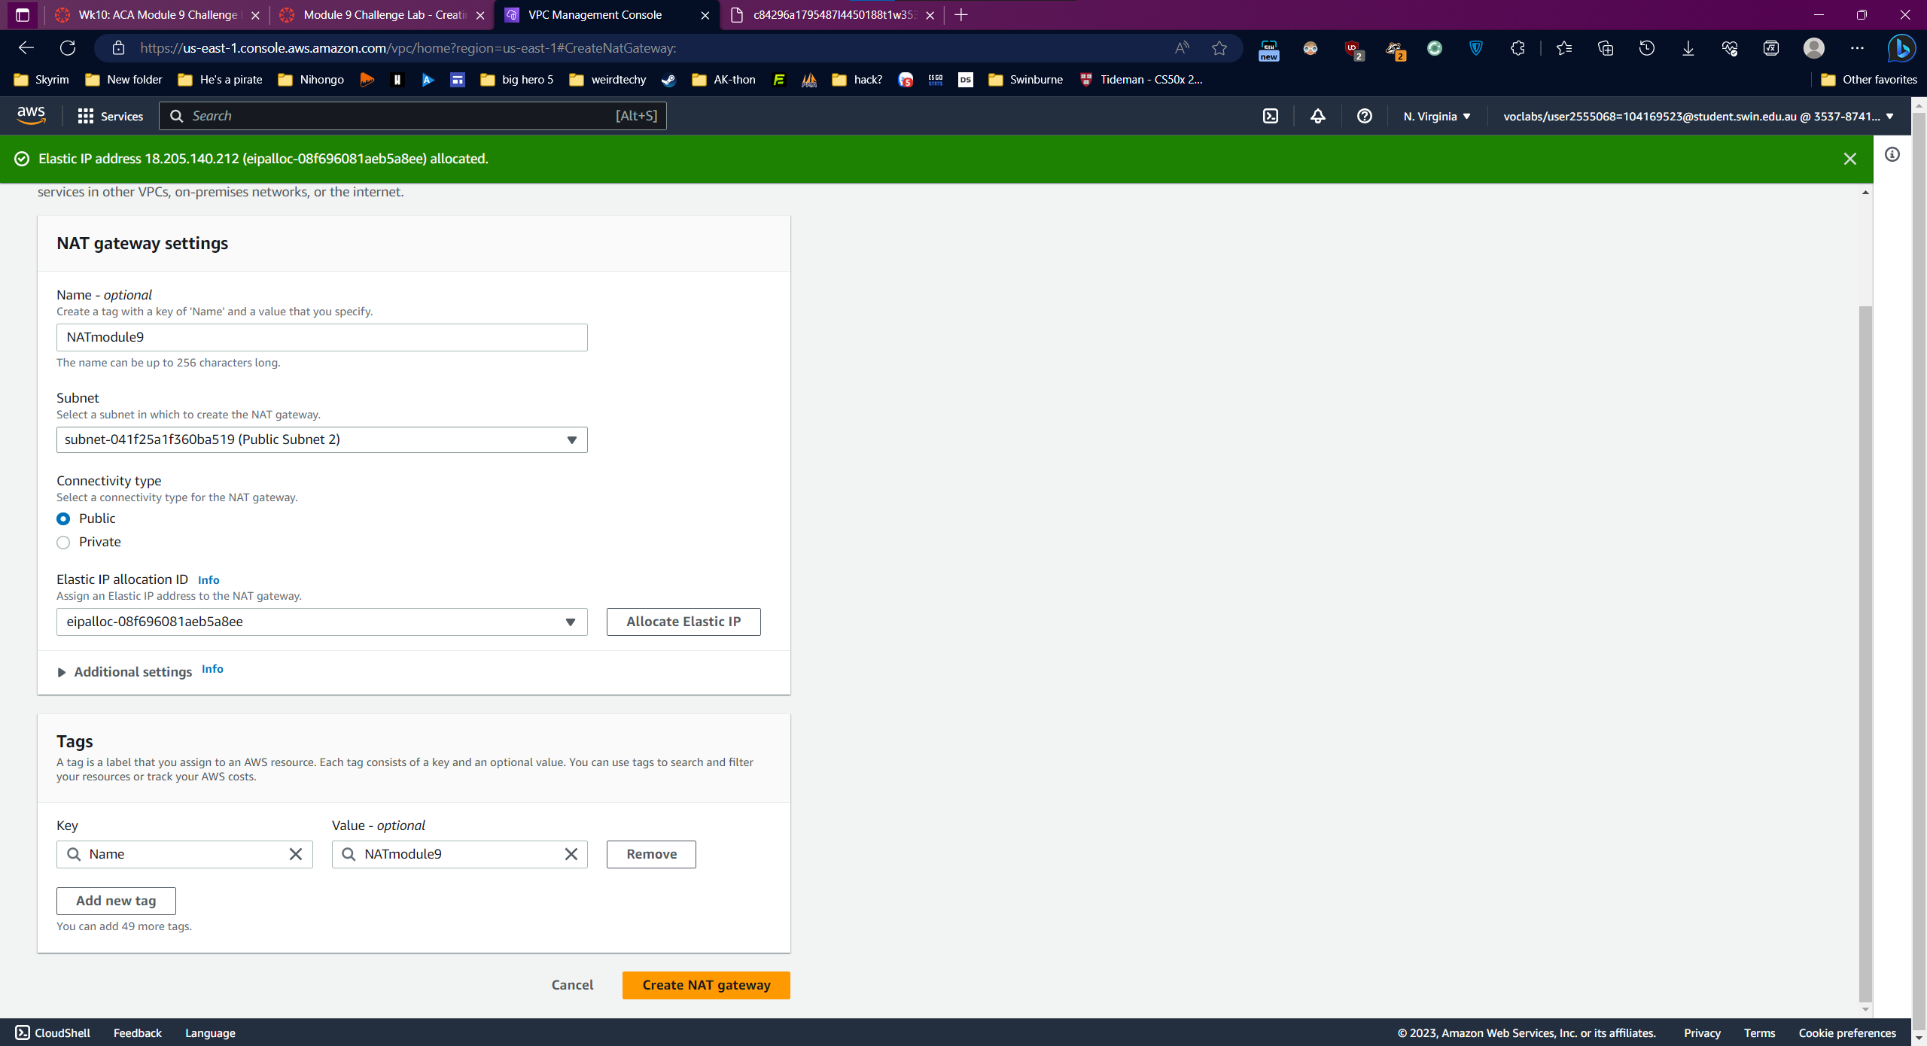

Update the Private Route table 2:

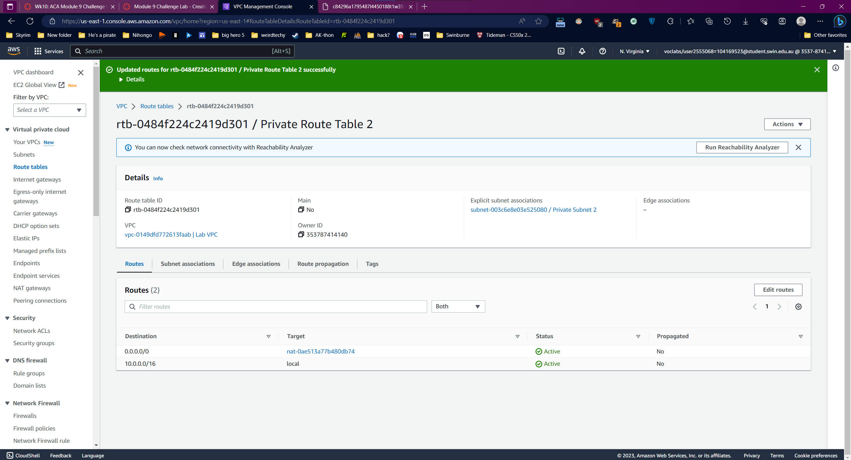

### Task 3: Creating a bastion host instance in a public subnet

Create EC2 instance

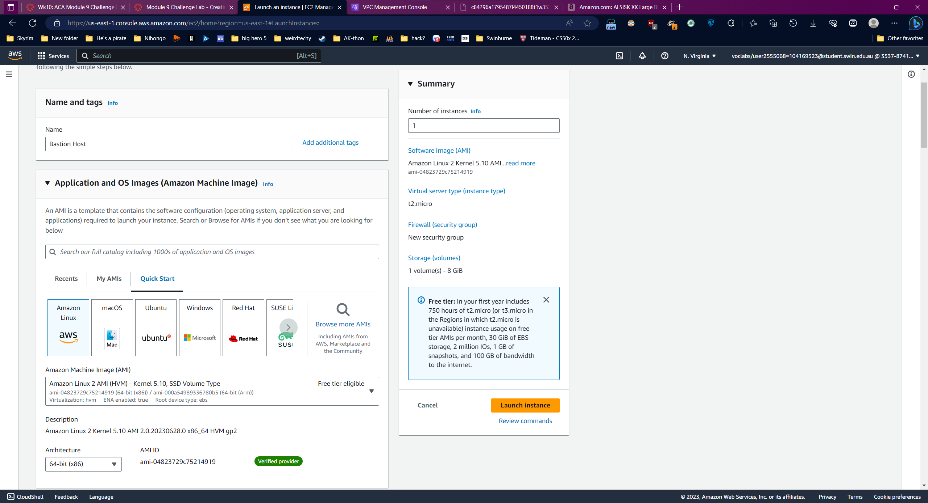

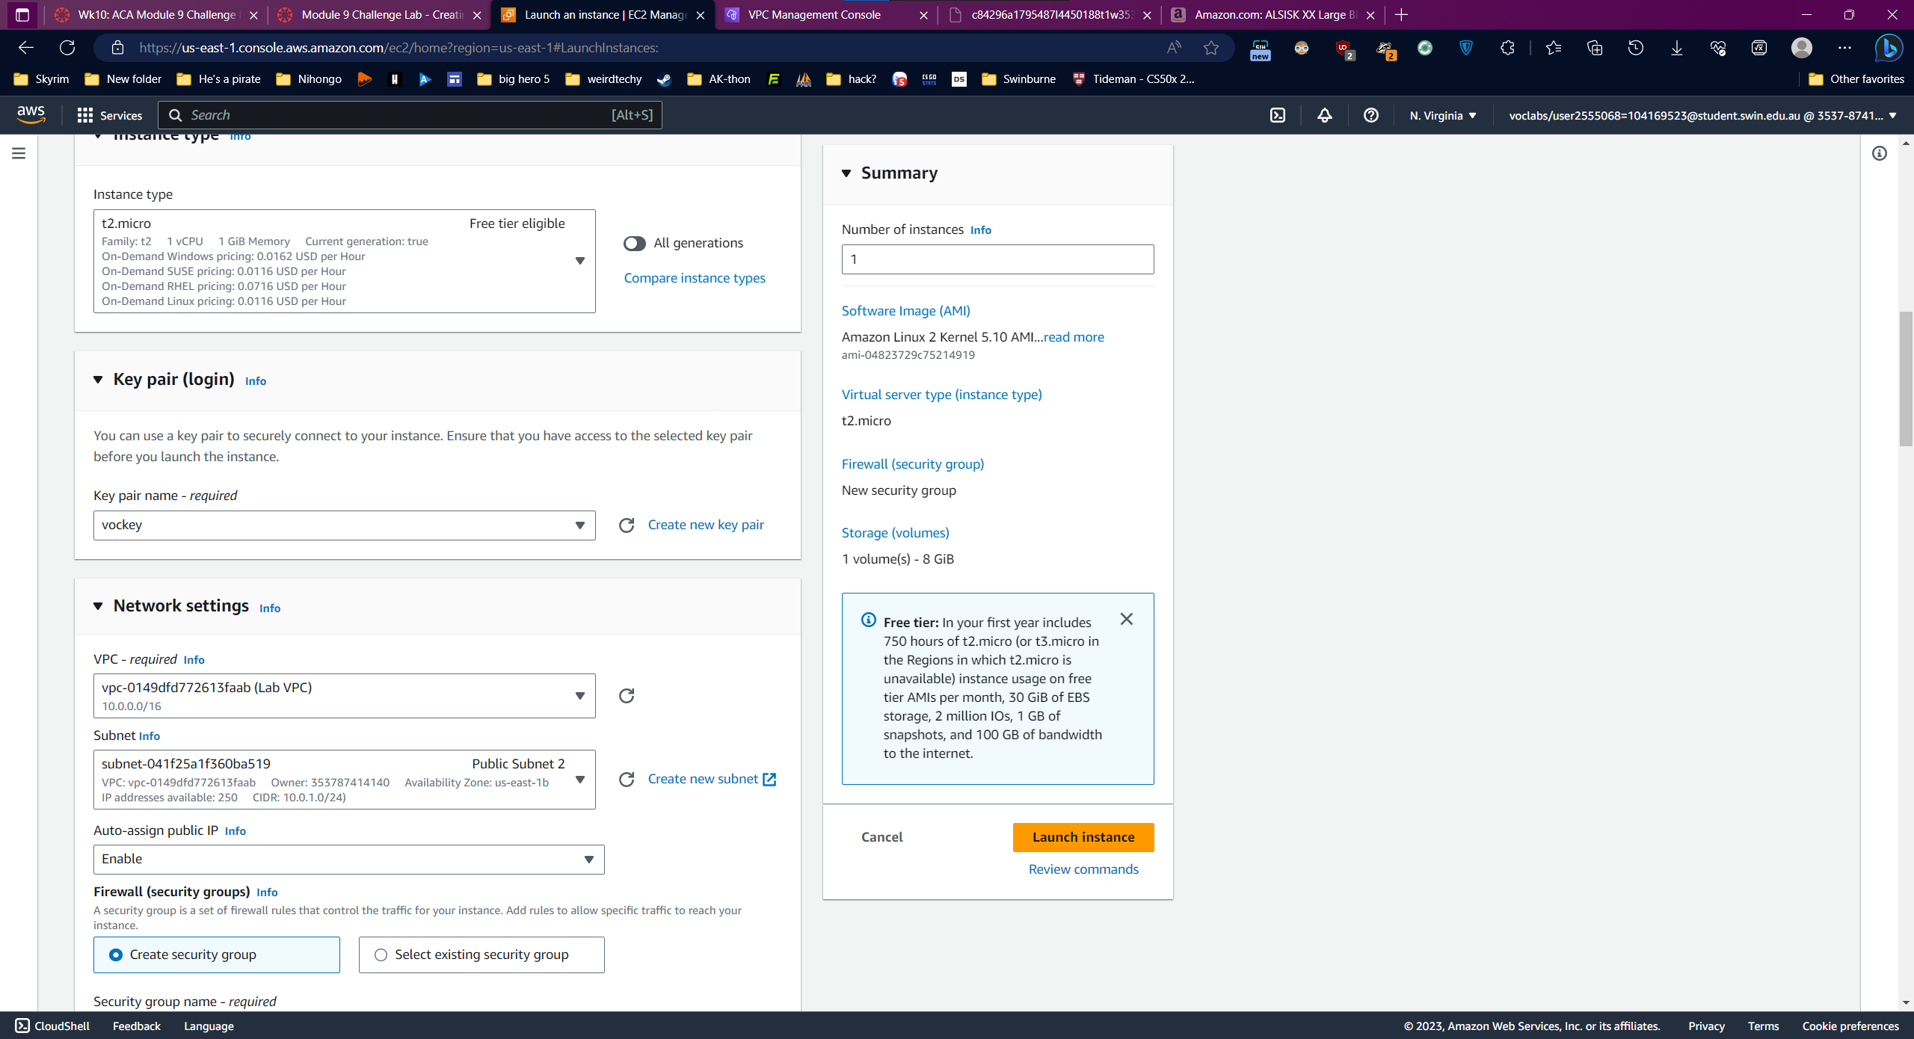

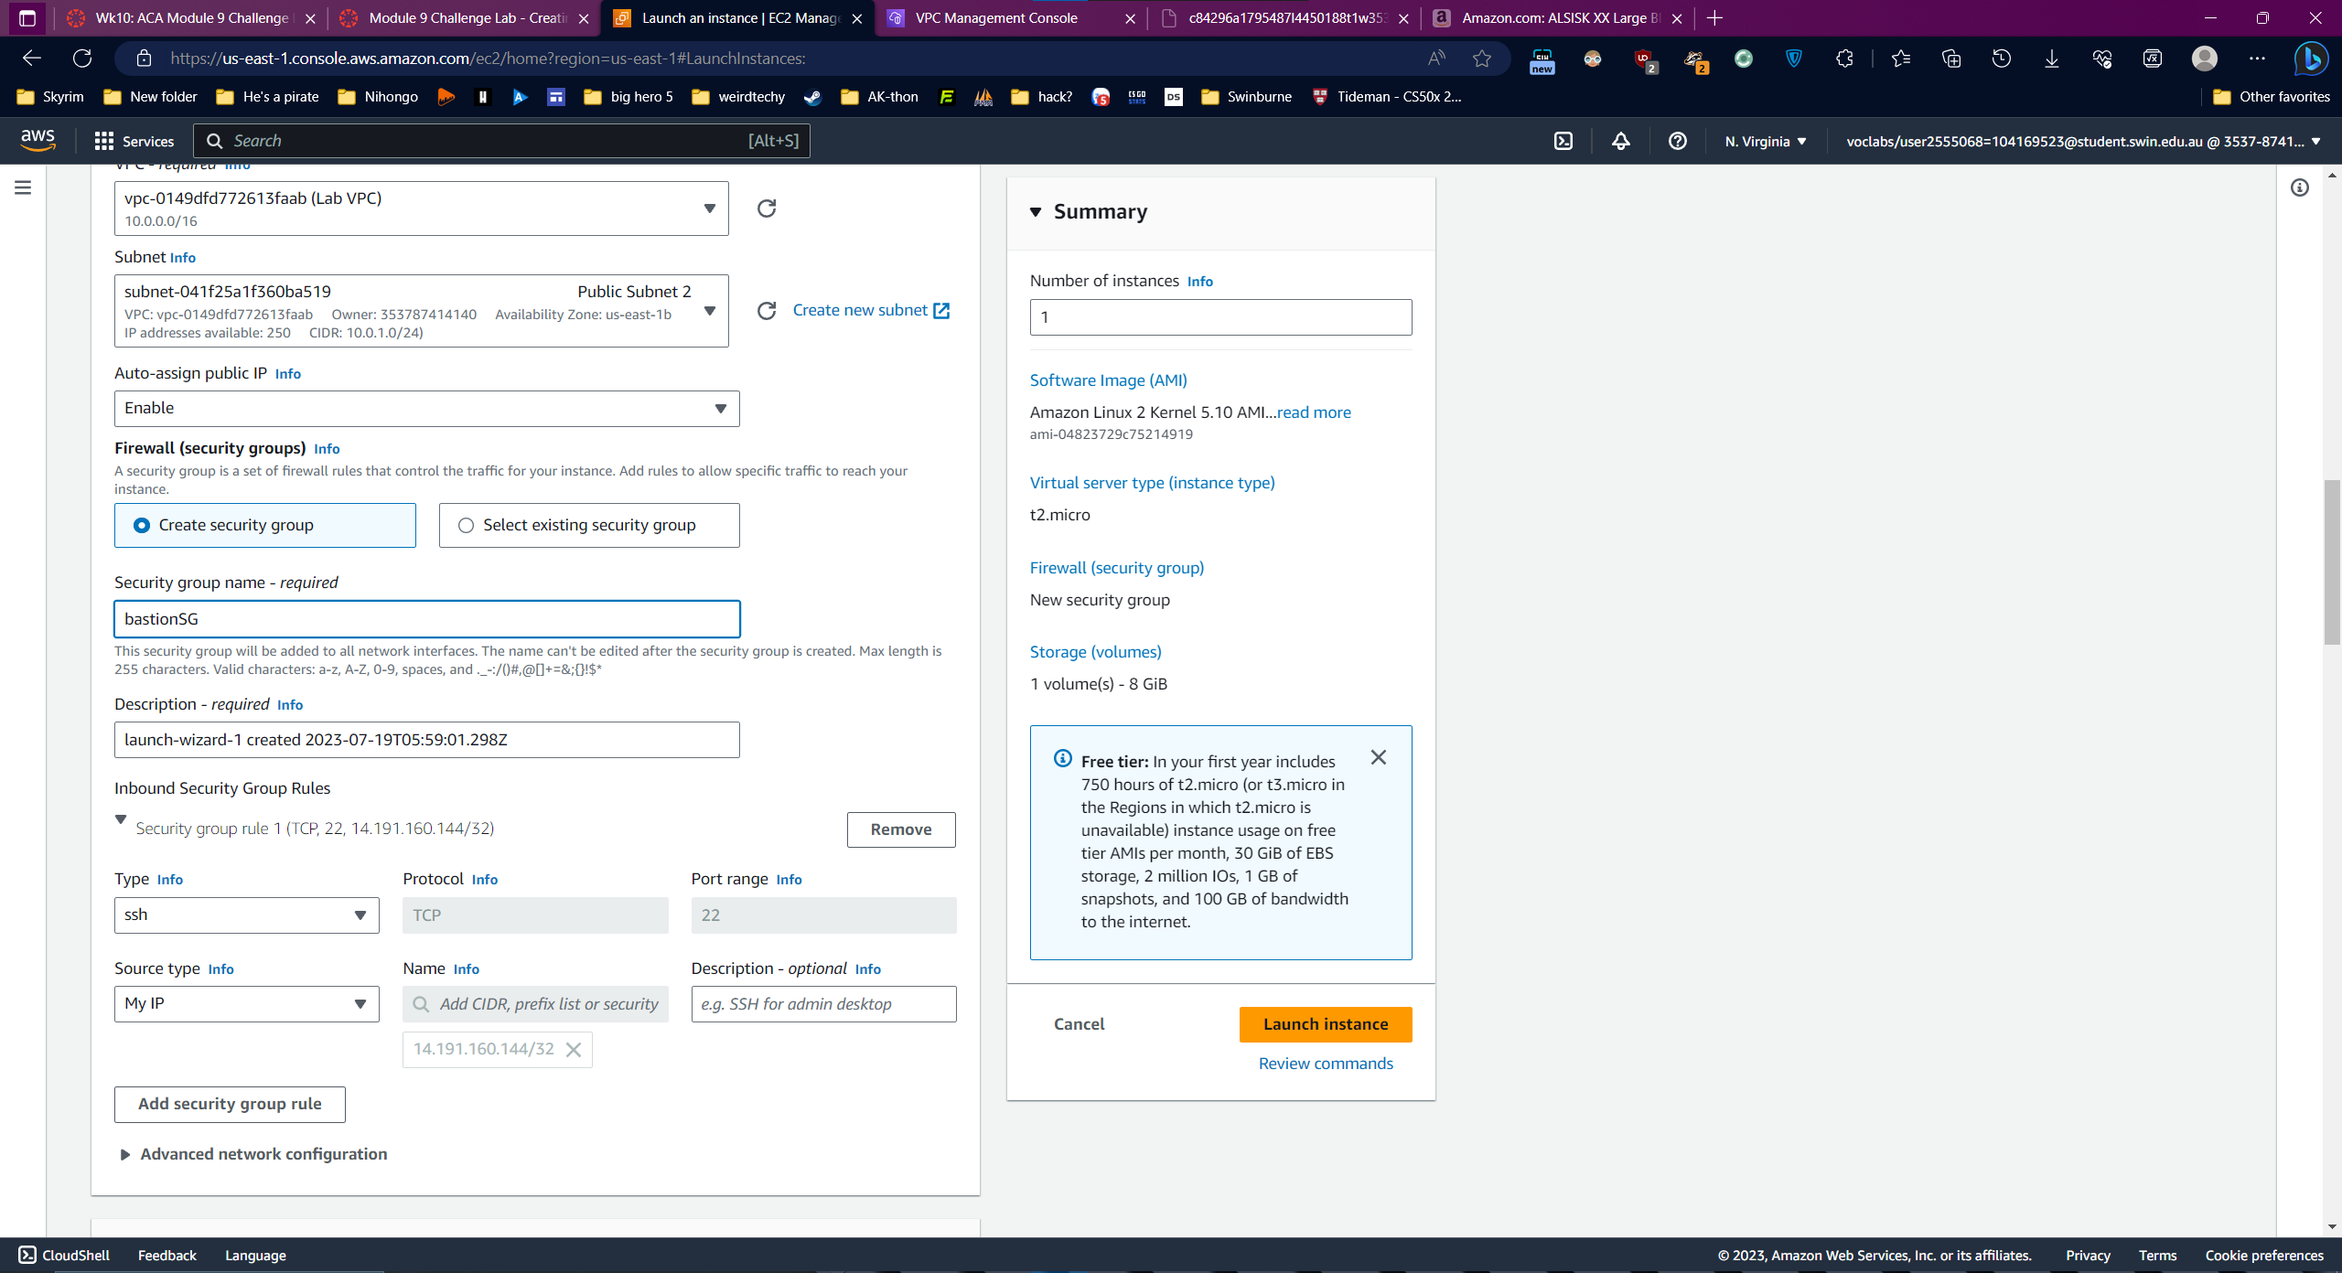

### Task 4: Creating a launch template

Create launch template

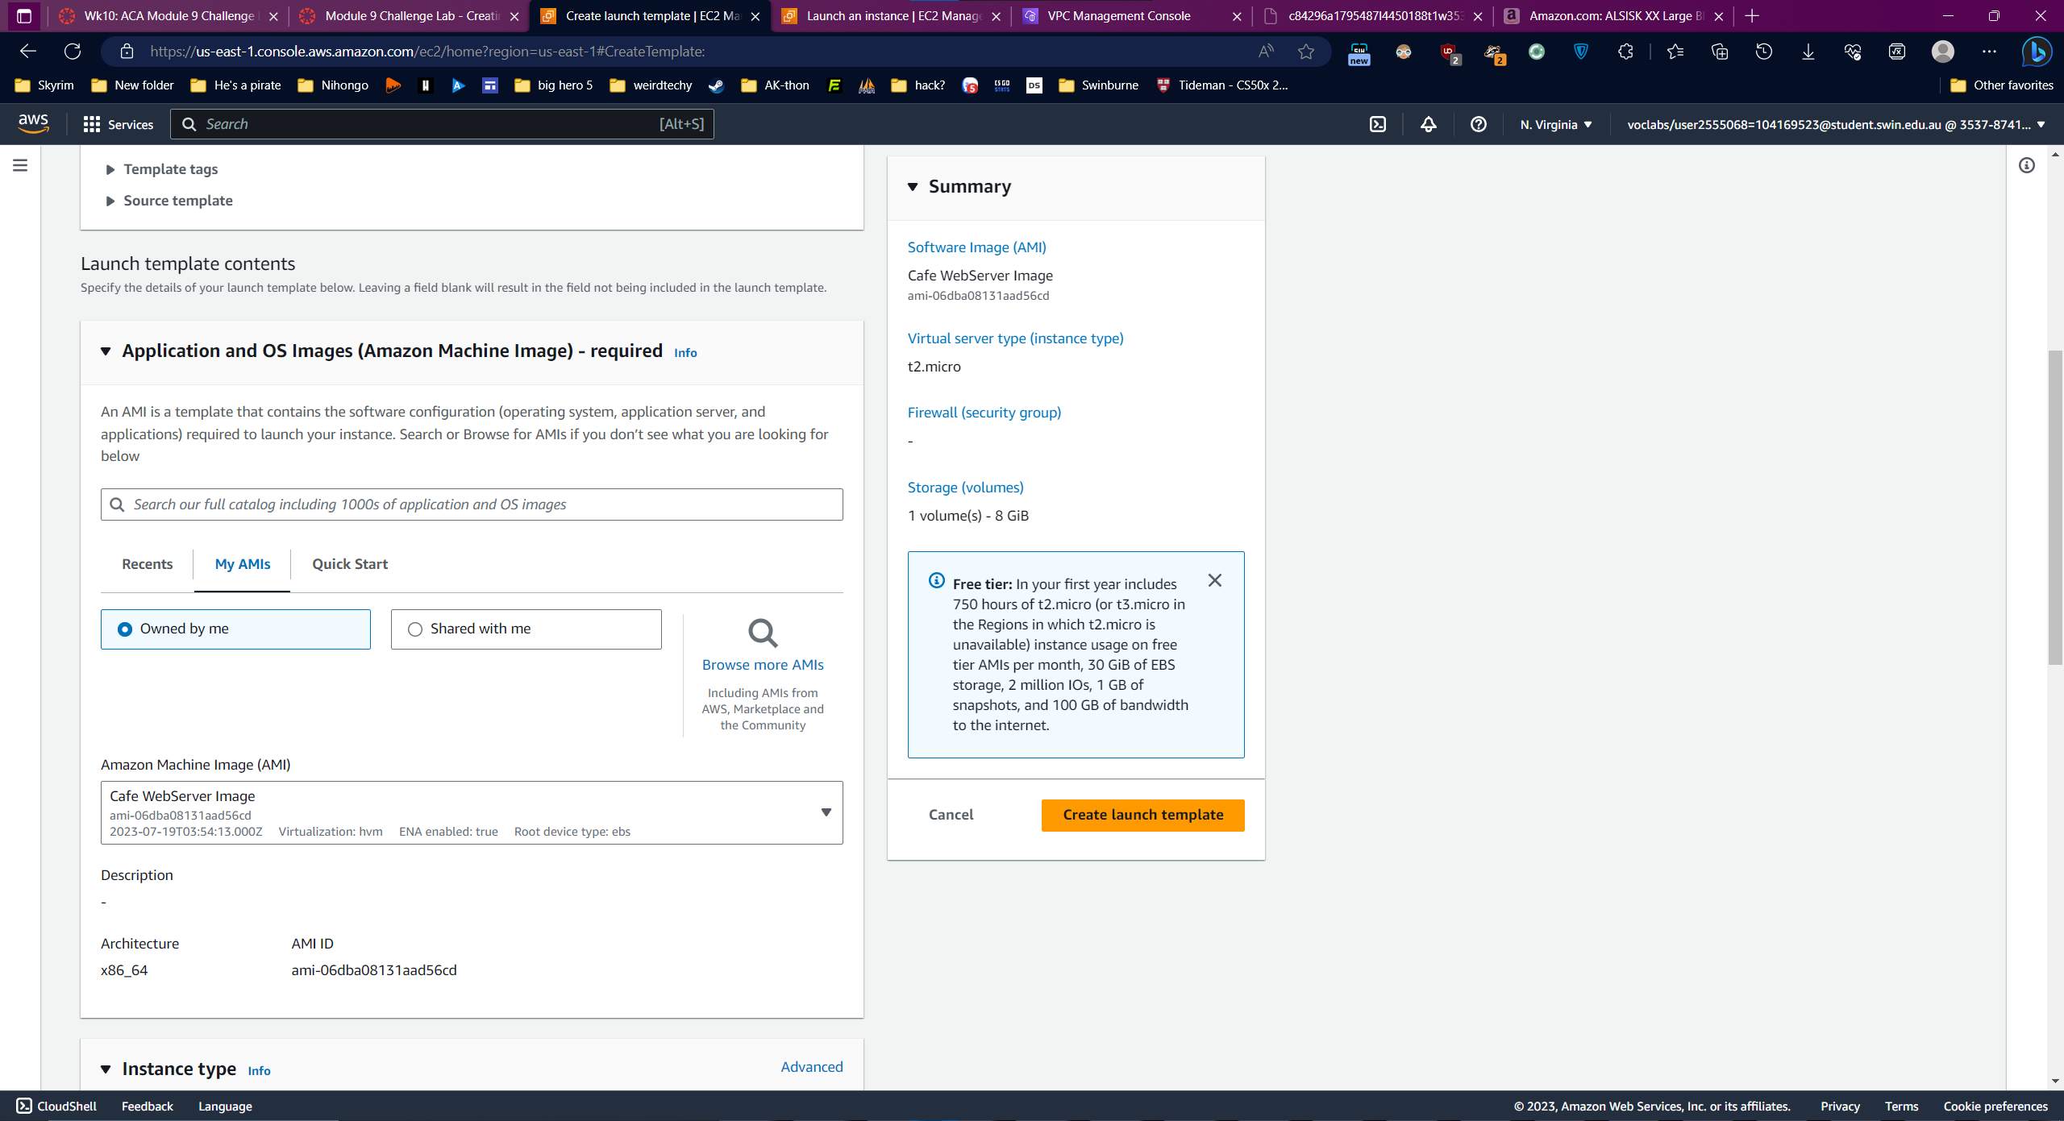

Create new keypair

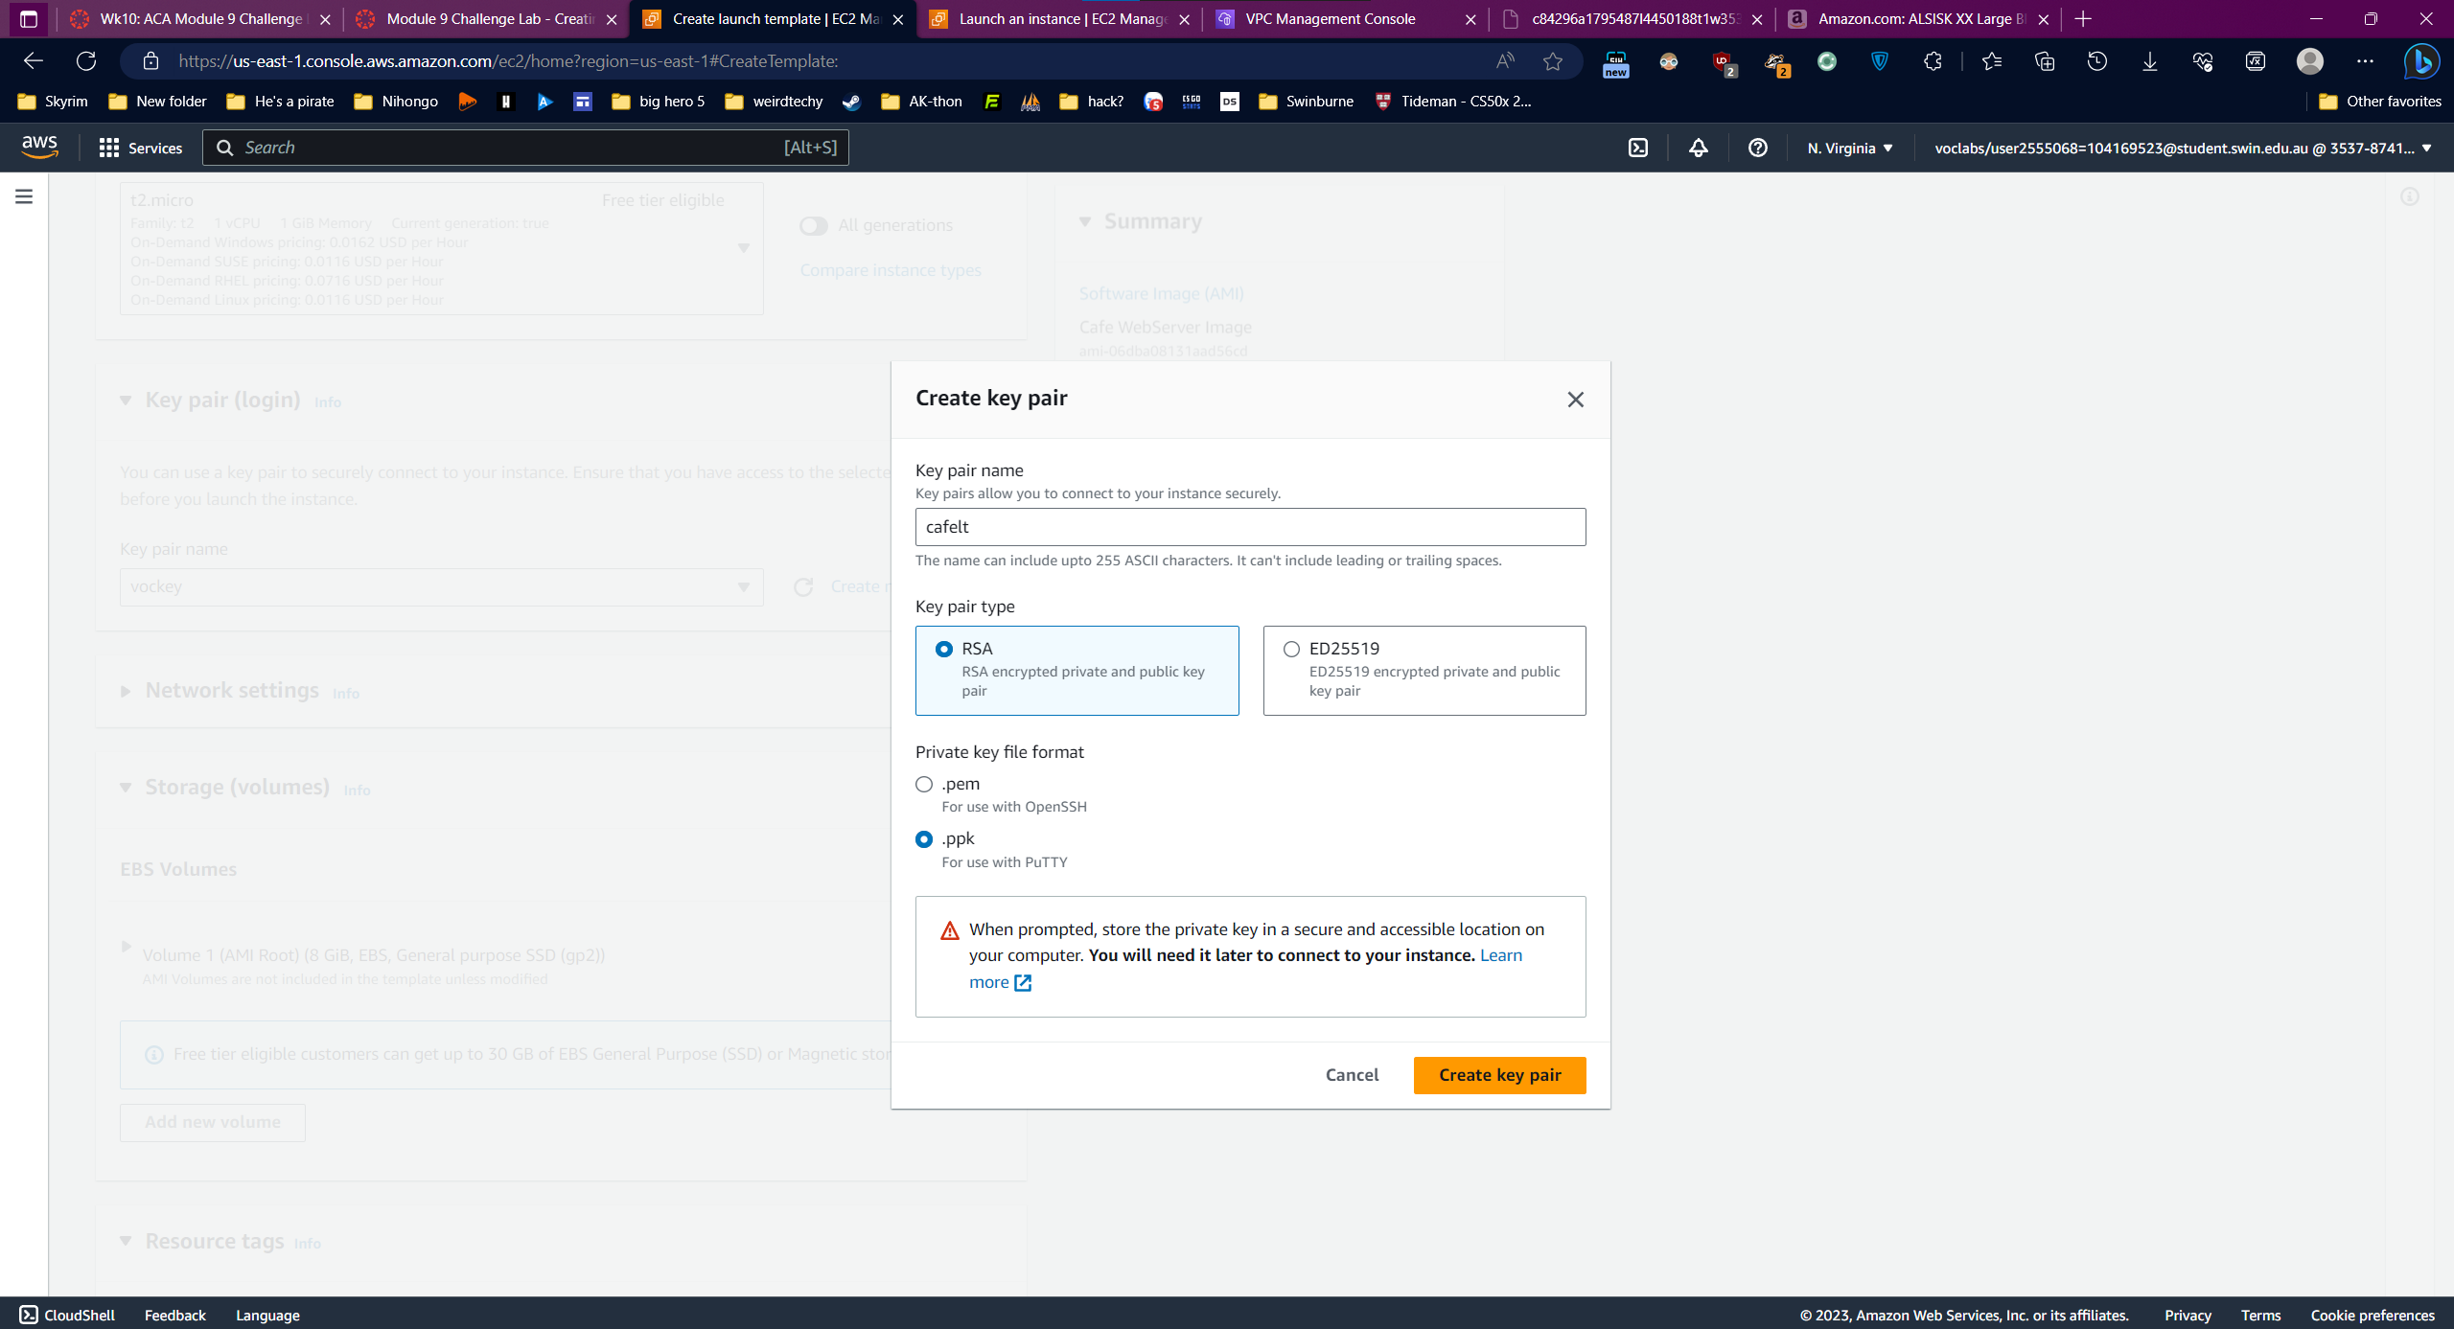

Network settings and Resources tags

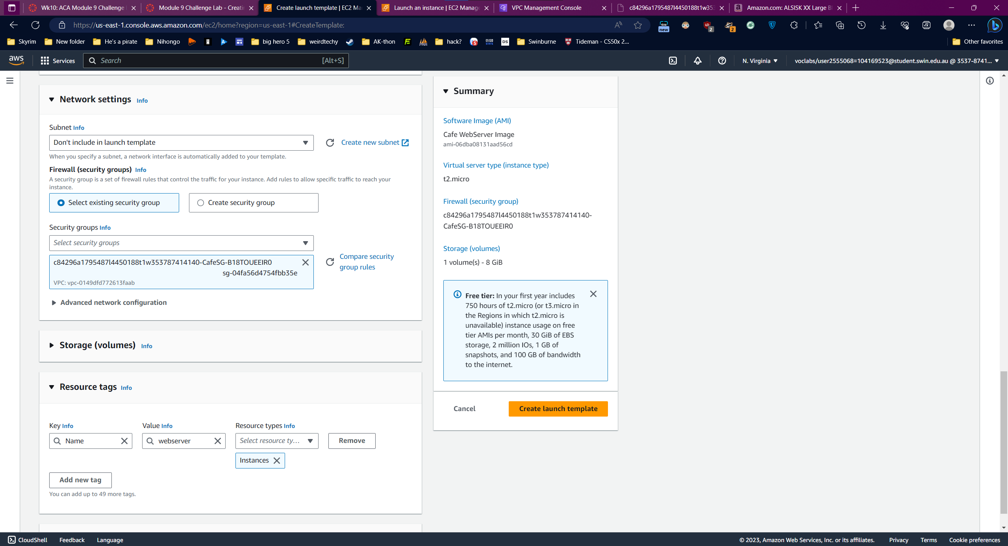

IAM role: CafeRole

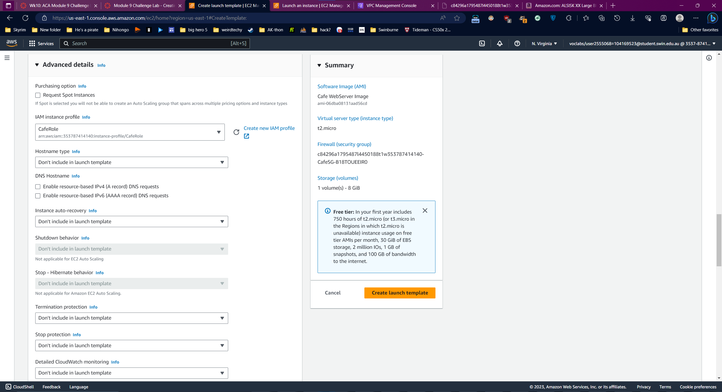

### Task 5: Creating an Auto Scaling group

Launch template: the previous one

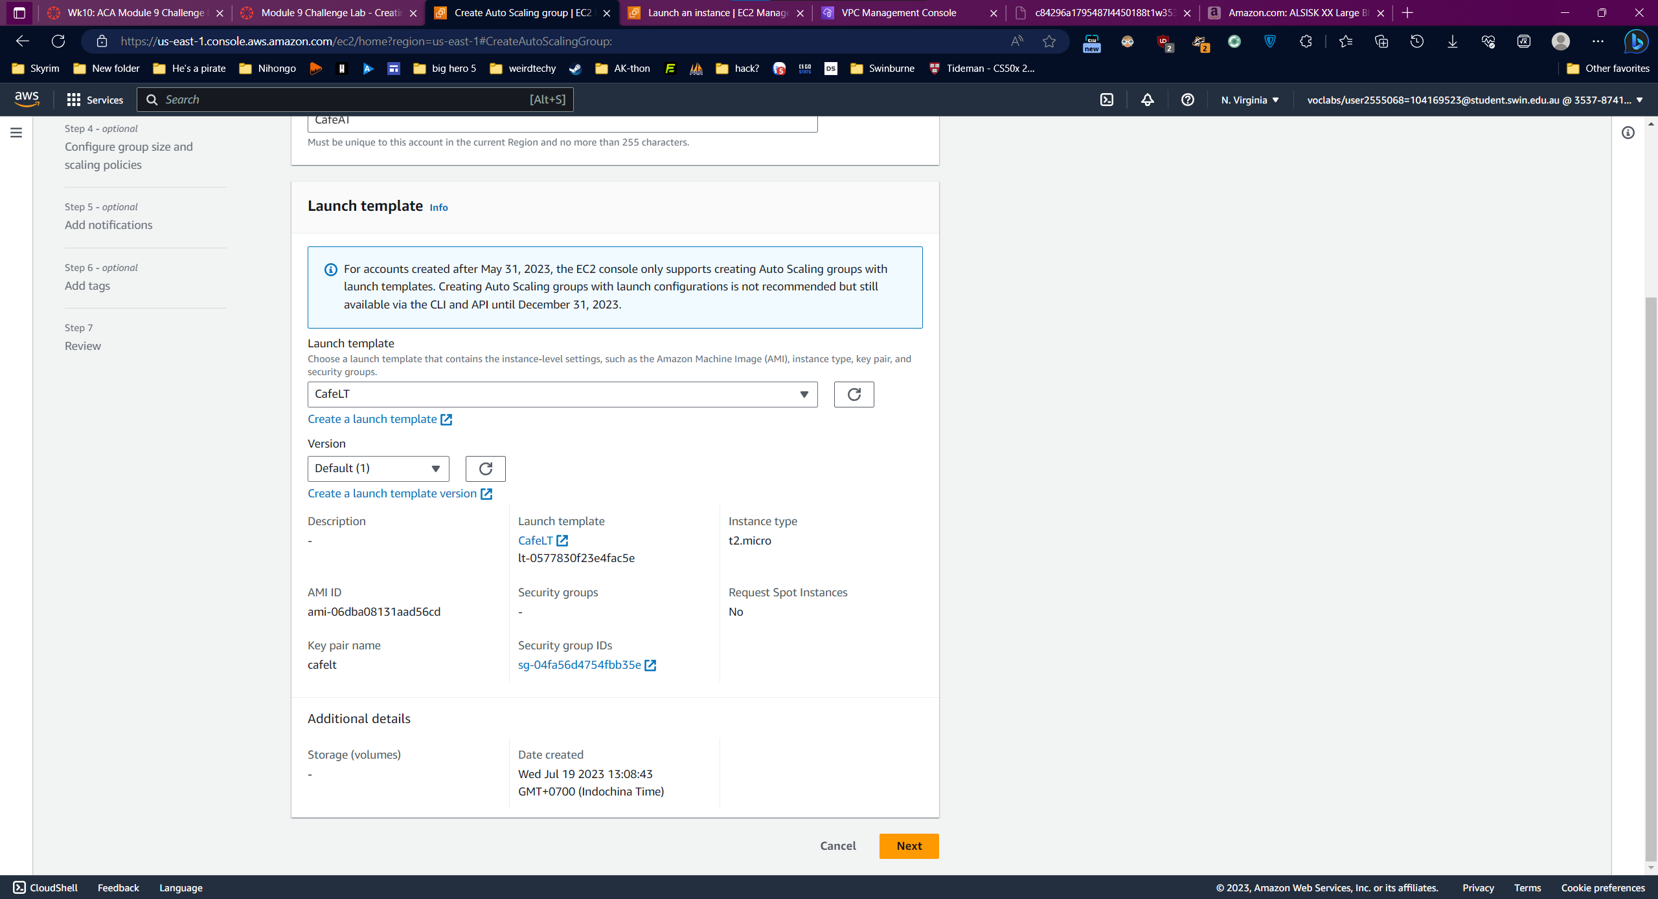

VPC and subnet

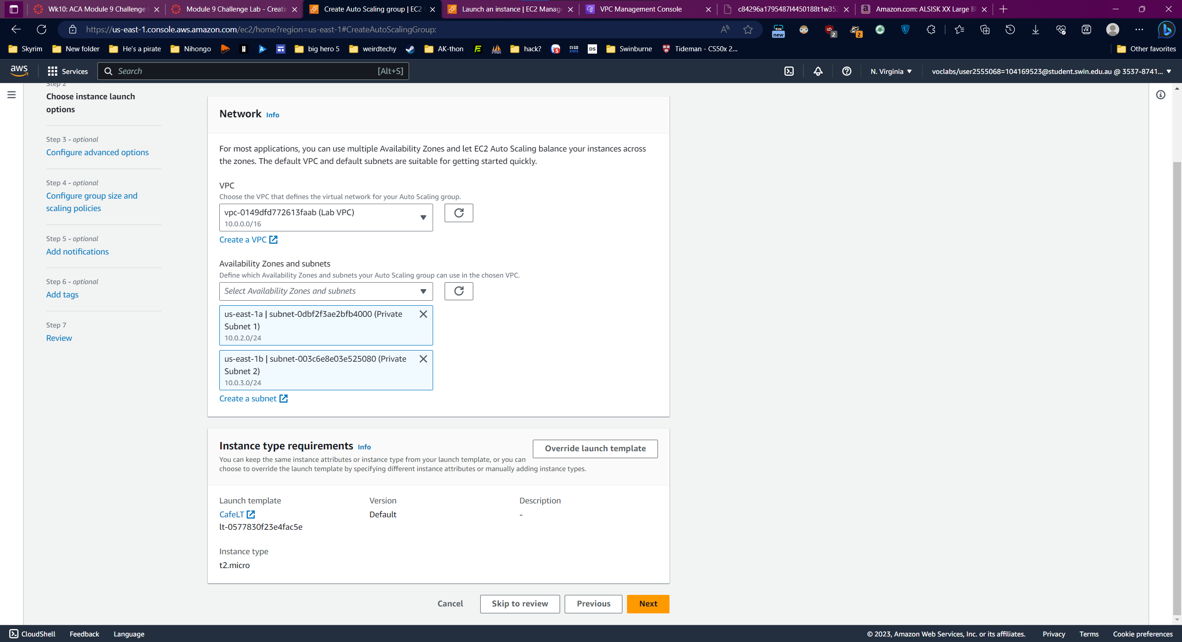

Group sizes and Scaling policy

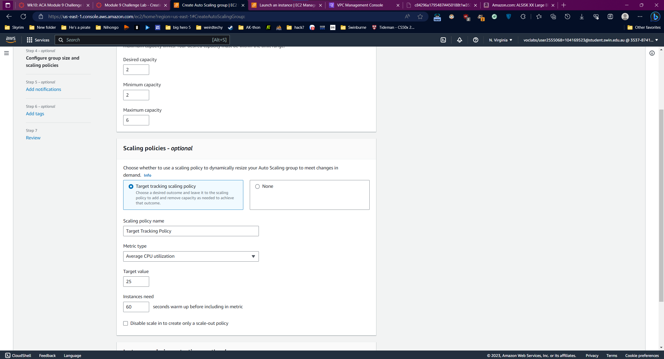

### Task 6: Creating a load balancer

Network Mapping

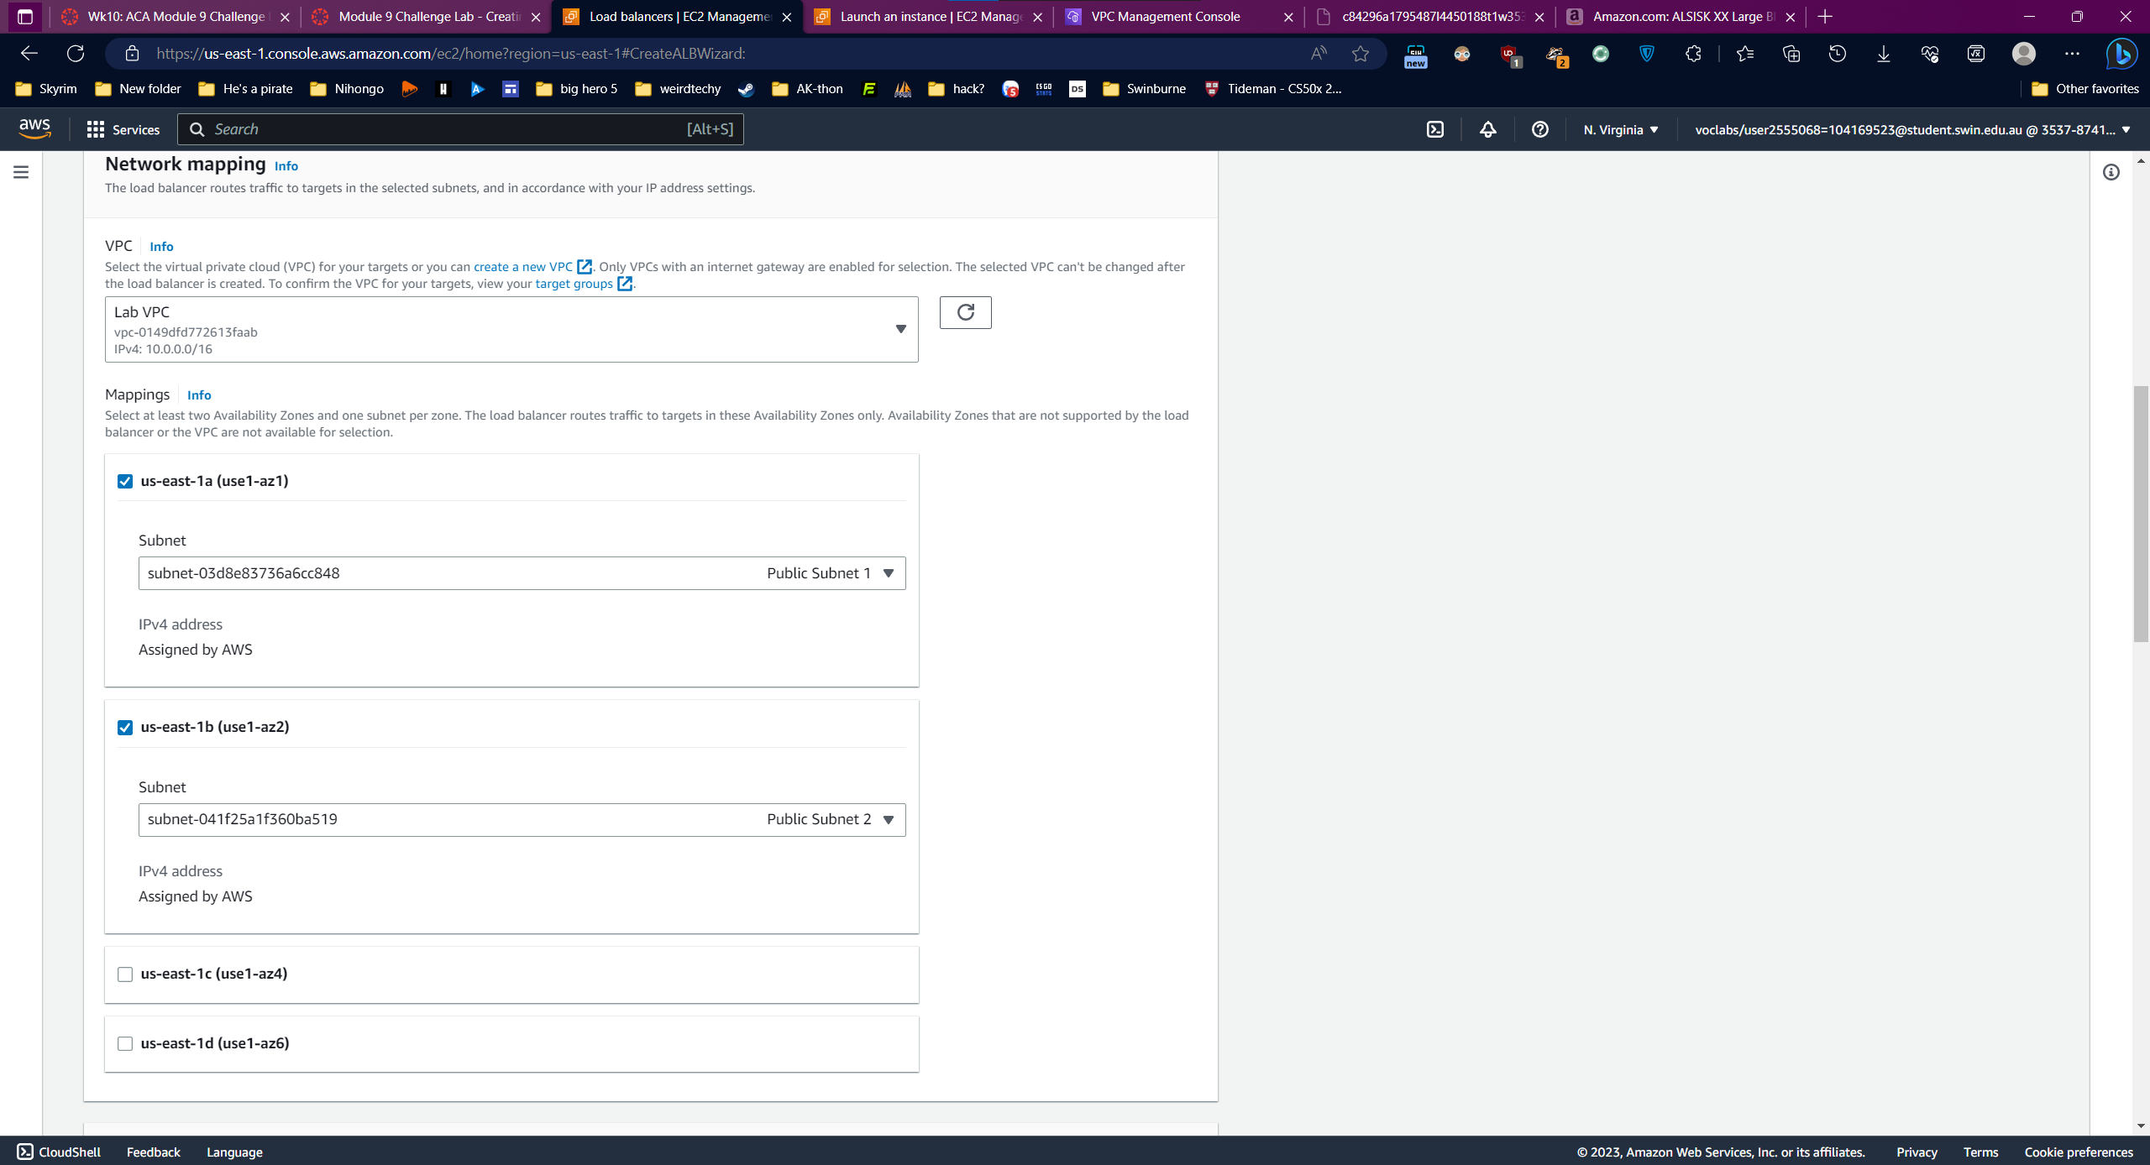

Create new security group

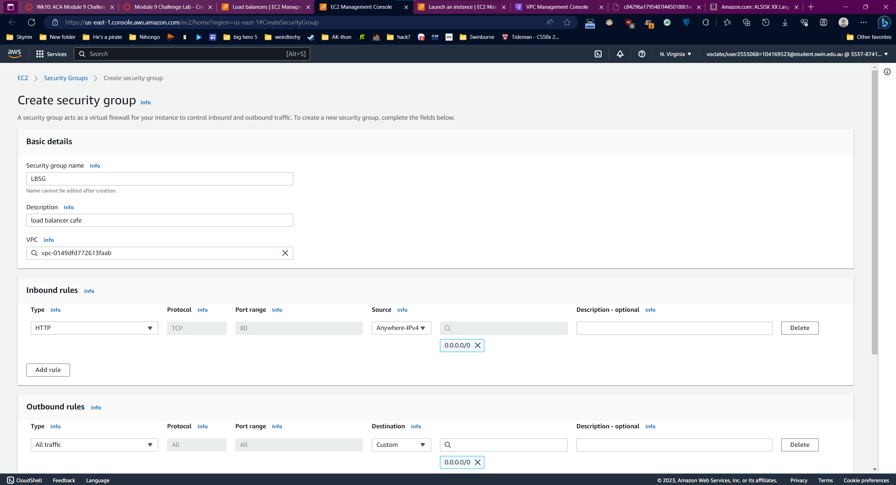

Create new target group

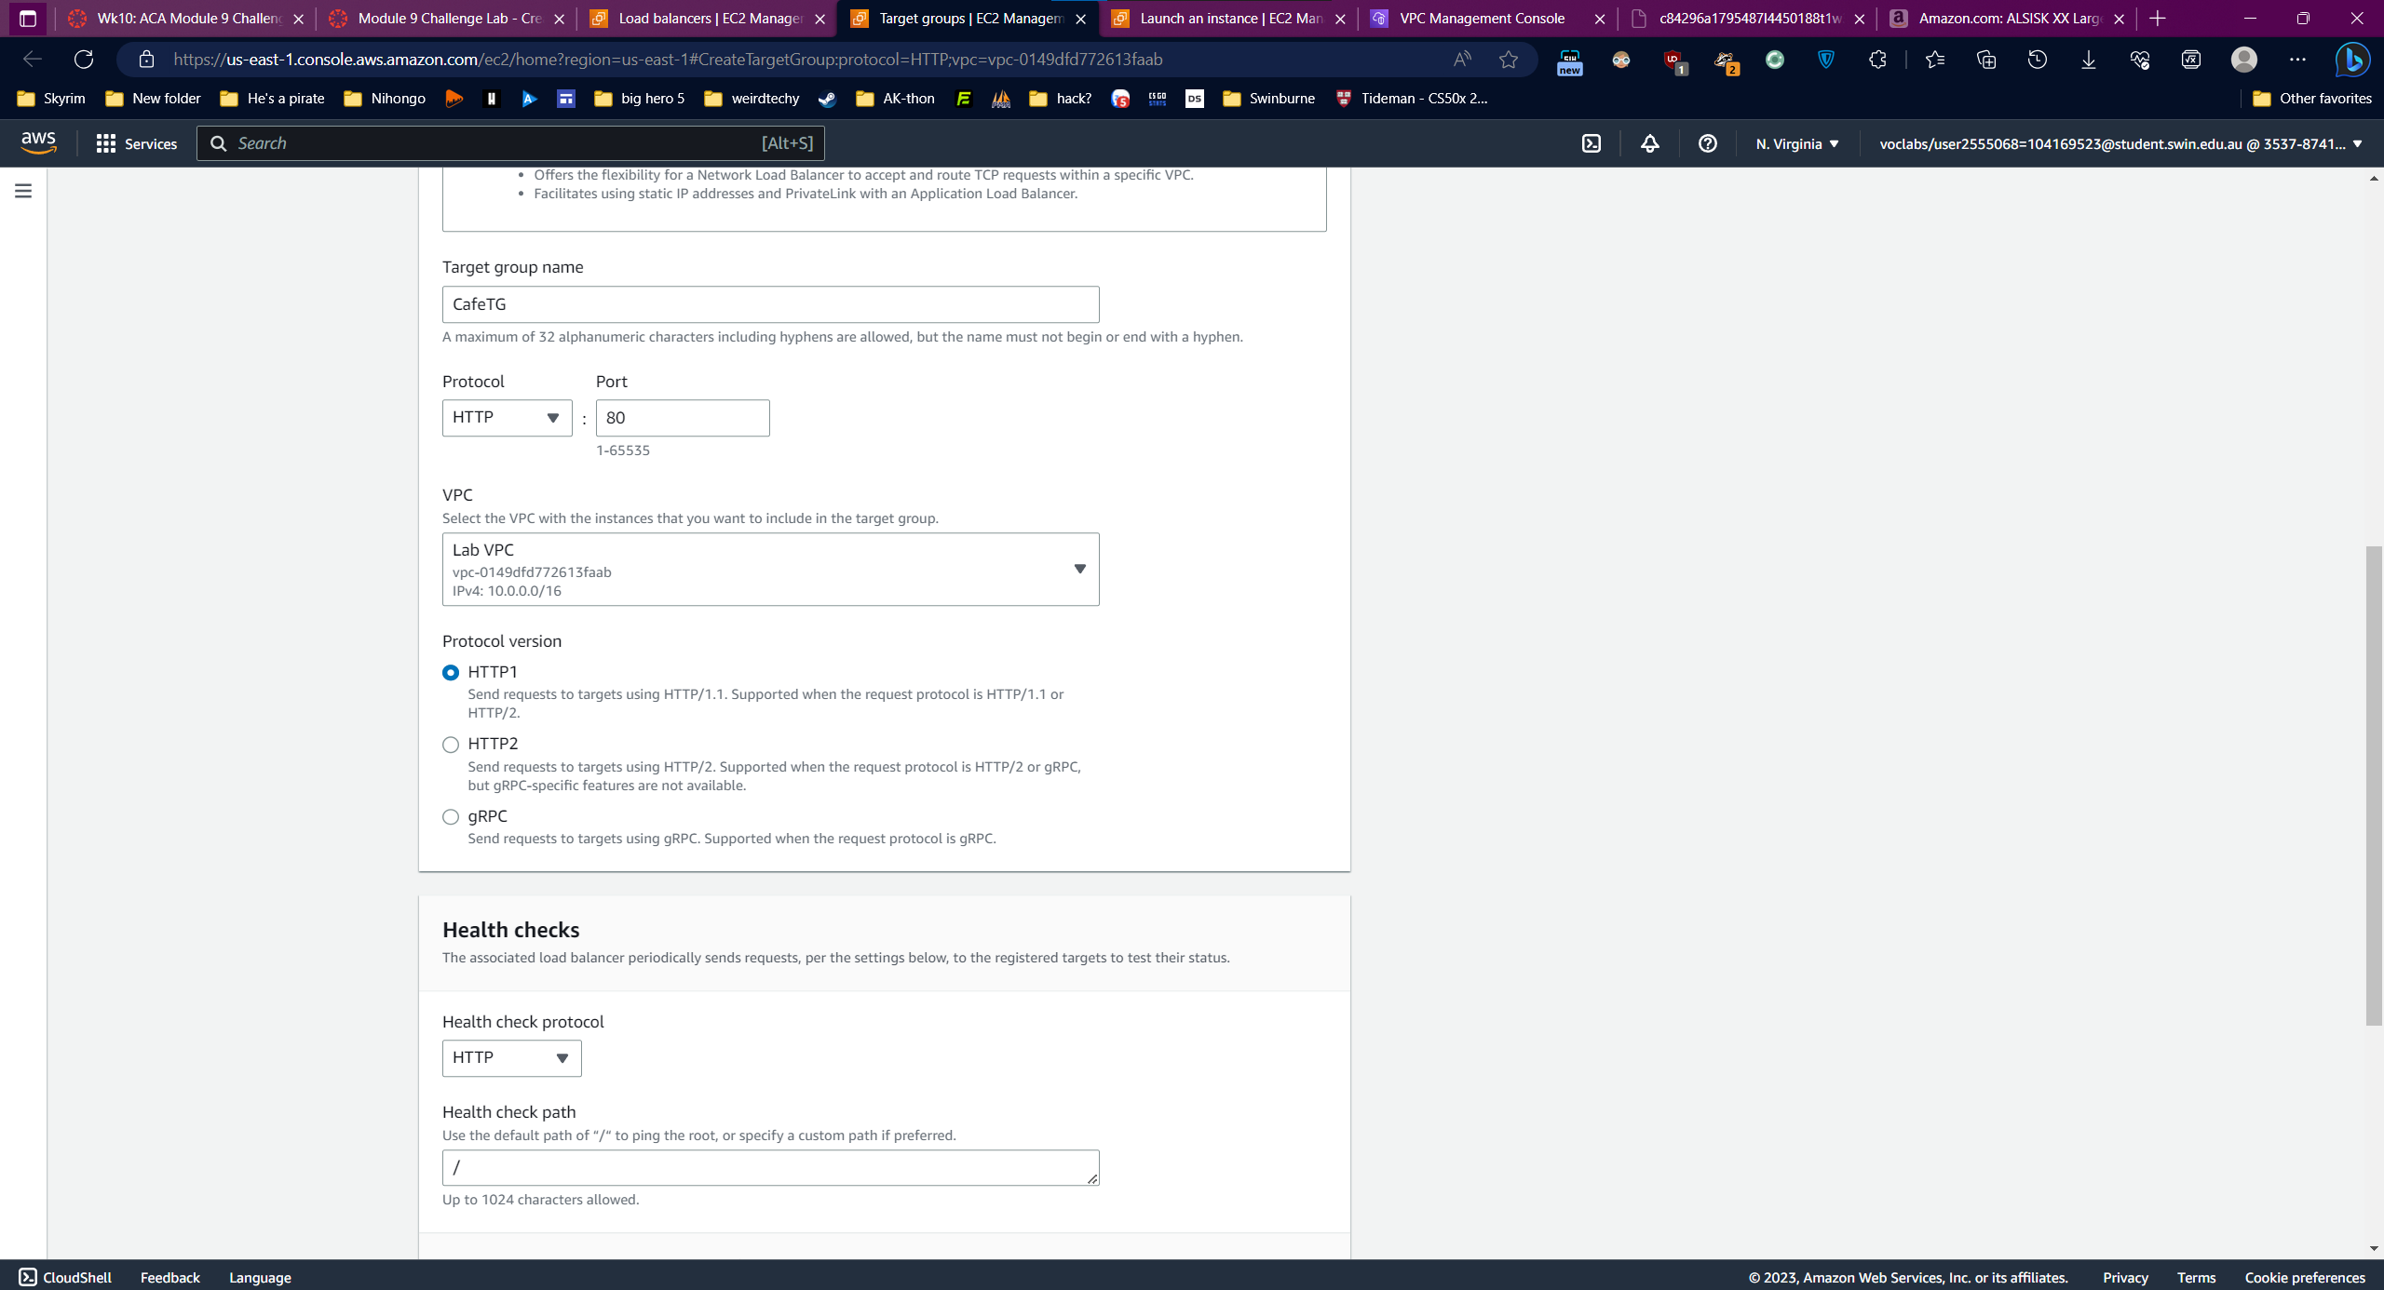

Add security group and target group:

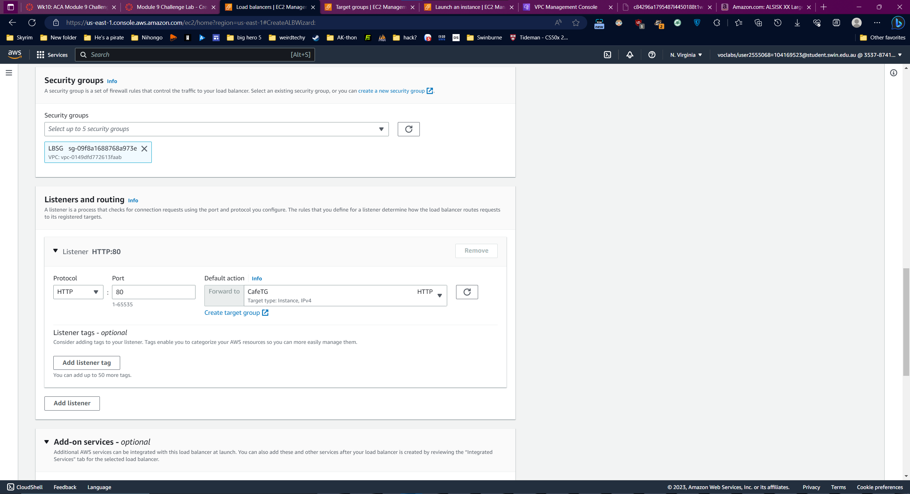

Add Load Balancer to Auto Scaling Group

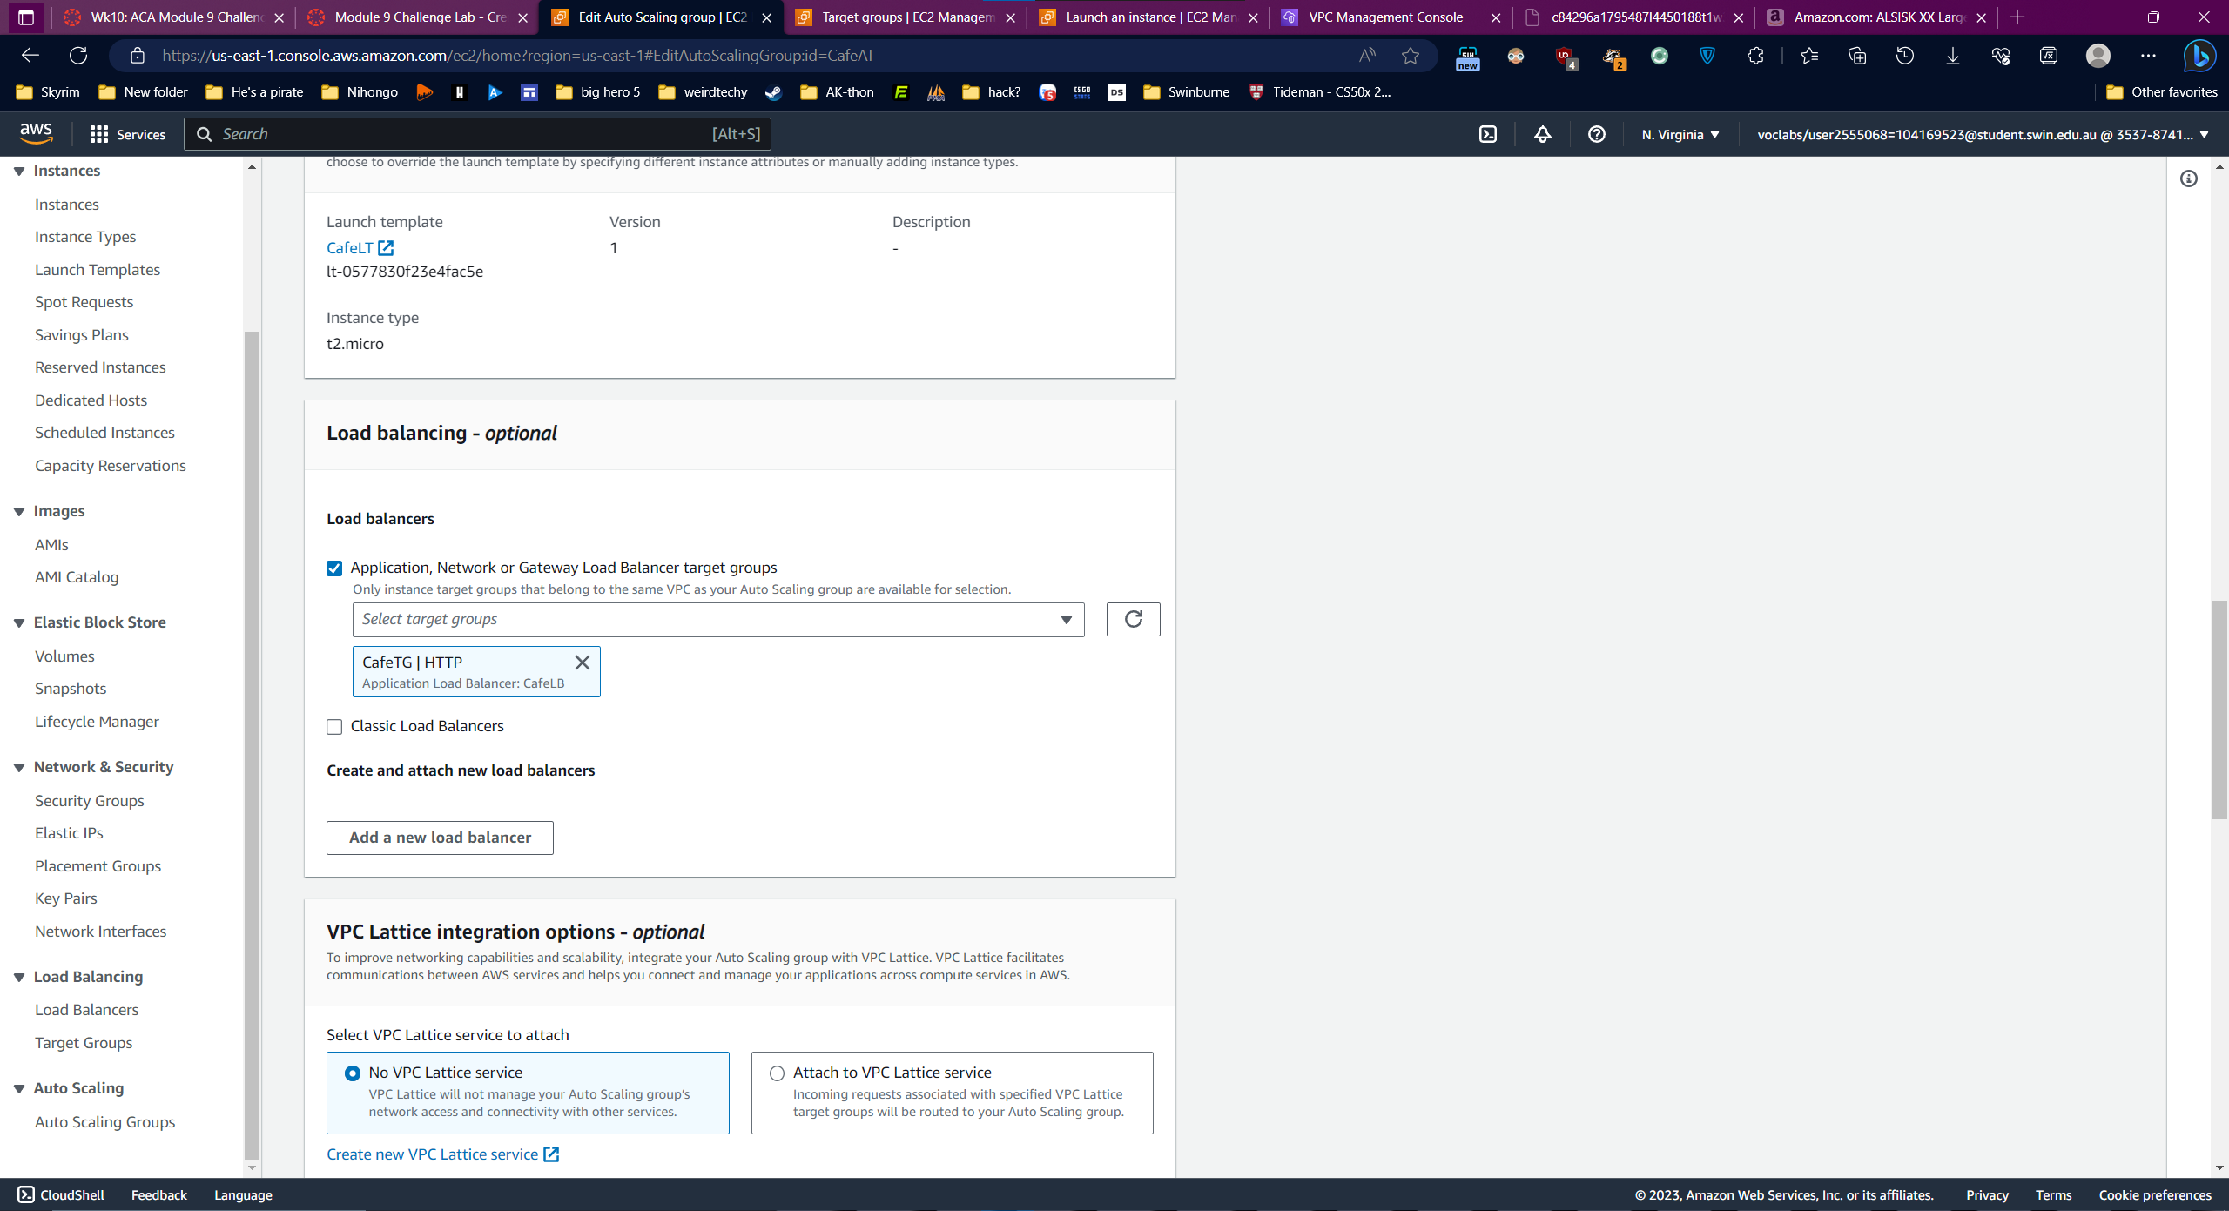

### Task 7: Testing the web application

Test the website

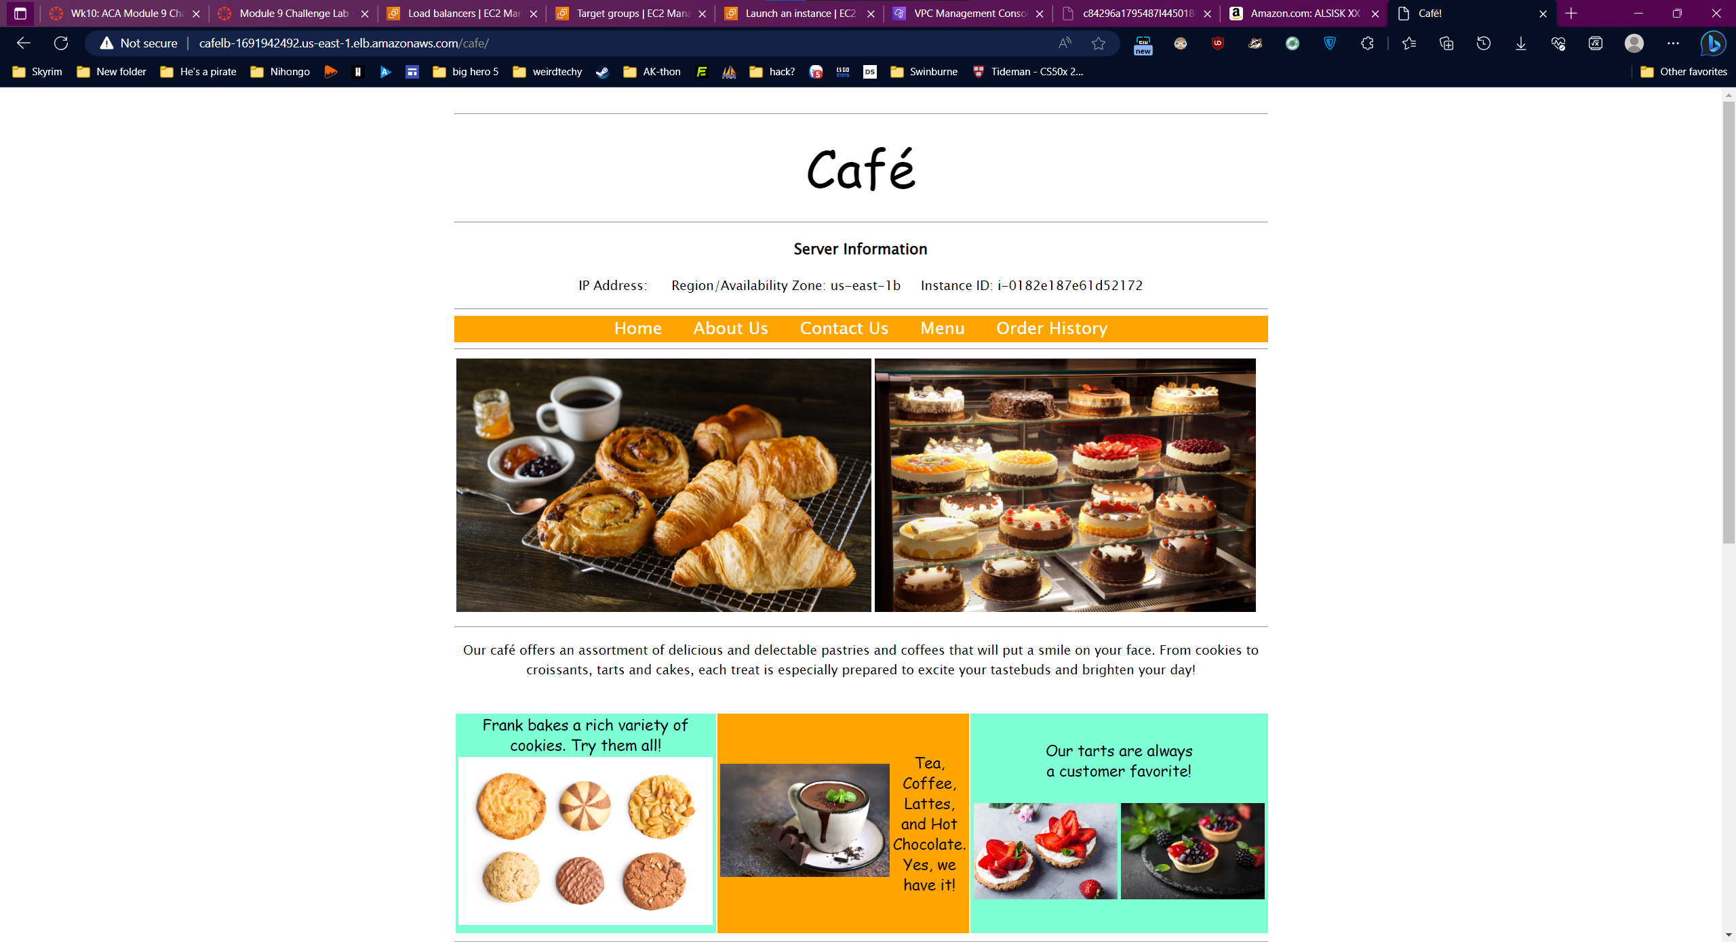

### Task 8: Testing automatic scaling under load

Change CafeSG security group

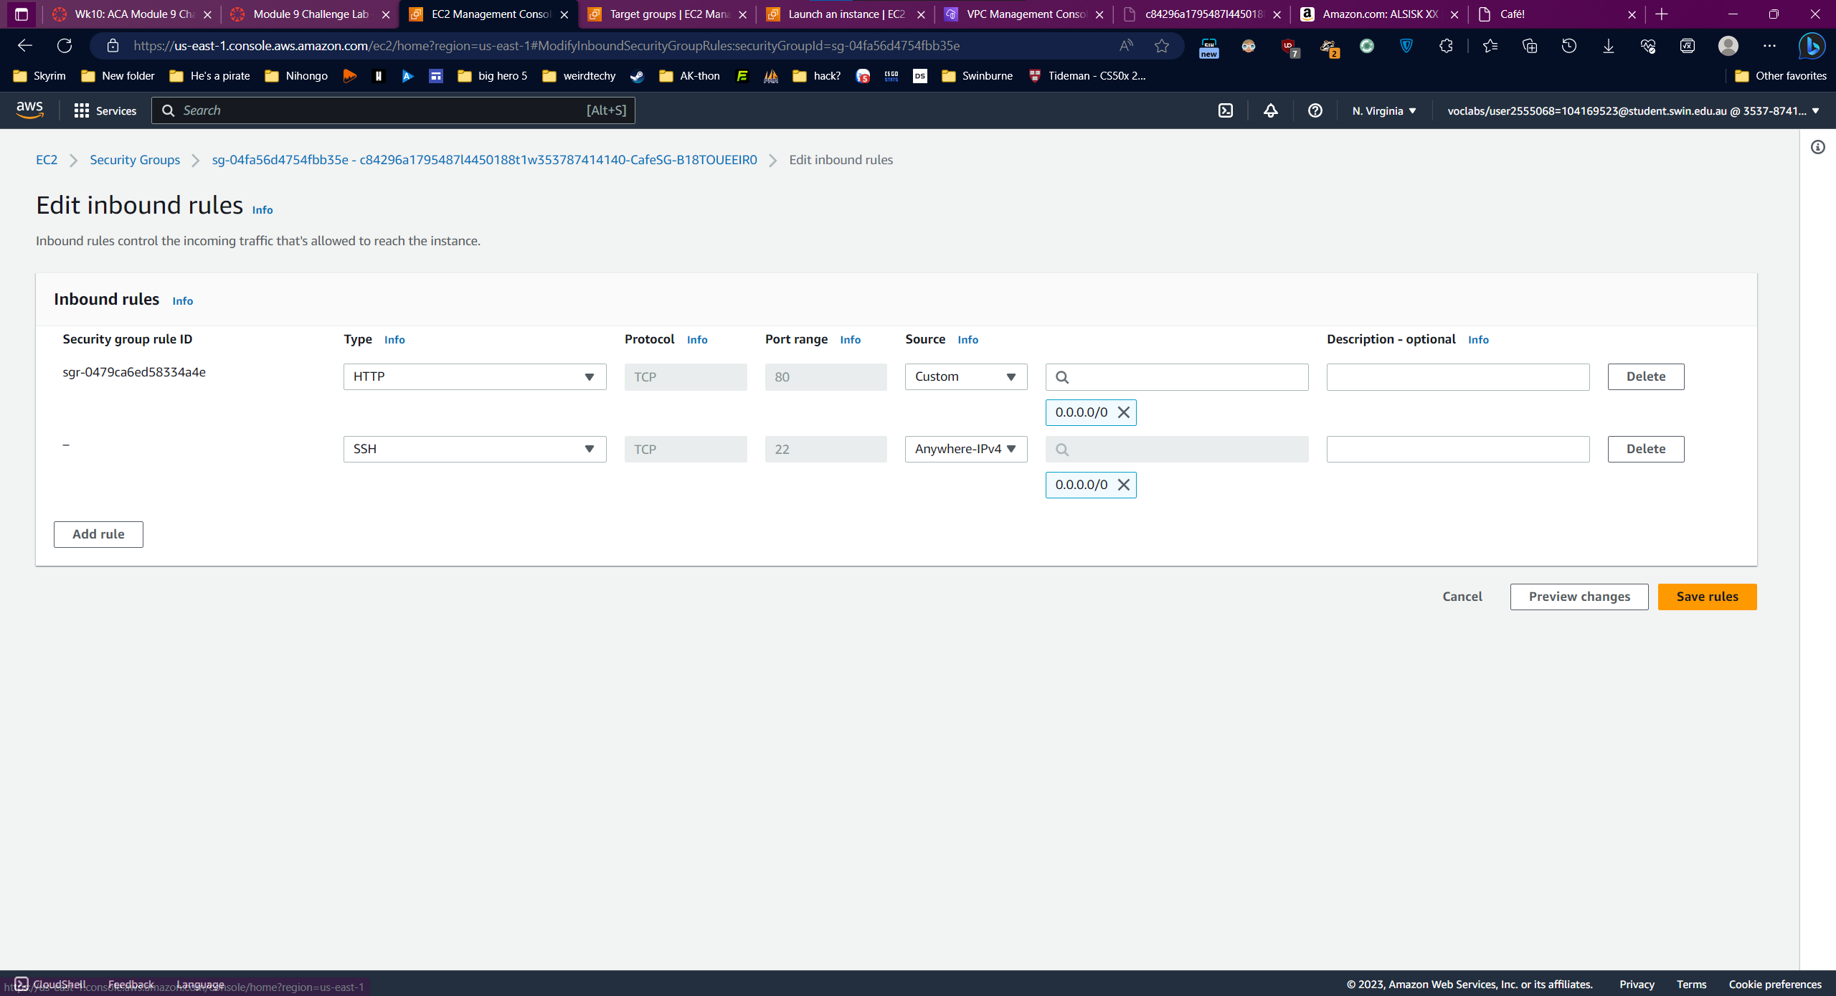

SSH to a webserver instance:

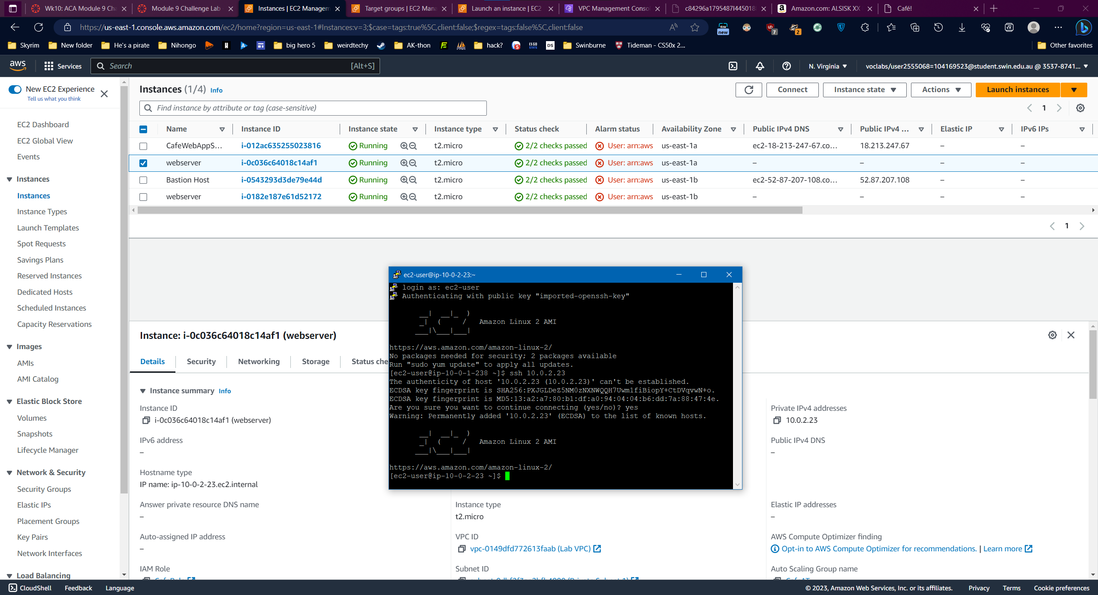

Copy the test command:

